AWS Bedrock

Version | : | 0.02 First Draft
Date | : | 2023-11-07
Author | : | Allan.benassi@aegon.co.uk

Version control
Version | Date | Author/updated by | Comments
0.01 | 2023-10-10 | Allan Benassi | First Draft :
0.02 | 2023-11-02 | Allan Benassi | Add Governance Control Layer
0.03 | 2023-11-17 | Allan Benassi | Add links to architectural standards
0.04 | 2024-07-29 | Allan Benassi | Update to get approval for all Account Deployments
0.05 | 2024-08-09 | Allan Benassi | Added details around thin blue line, concerns and governance model

Note:
Dates in ISO format: YYYY-MM-DD
Versions: 0.XX Pre-release, n.XX Release, n.XX.xx draft releases of version under version control
Table of Contents
Overview 5
Driver 7
Value 8
Considerations 10
Security 10
Cost Optimization 10
Operational Excellence 10
Reliability 10
Performance Efficiency 10
Sustainability 11
Functionality / How it Works 12
Architectural Attributes 13
Interfaces 13
Redundancy, Availability & Reliability 13
Scale, Elasticity & Capacity 13
Cost, Business & Support Models 13
User Access & Roles 14
Federated Roles & Access Control Policies 14
Restrictions 15
Permitted Regions 15
Operational Deployment Models 16
Centralized Model 16
Federated Model 17
Federated + Model 18
Thin Blue Line 18
Security Control Polices 18
Risk and Concerns 19
Business Unit Use Cases Operations 22
Use Cases 23
Data & Governance 25
Data Classification 26
Guardrails 26
Product / Component Selection 31
Feature Comparison 32
Exceptions 32
Usage in TransAmerica / Aegon 34
Related Component Standards 34
Architectural Patterns 34
Reference Architecture 34
Solution Architectures 34
Components Referenced in this Document 35

Overview
Amazon Bedrock is a fully managed service that offers a choice of high-performing foundation models (FMs) from leading AI companies like AI21 Labs, Anthropic, Cohere, Meta, Stability AI, and Amazon with a single API, along with a broad set of capabilities you need to build generative AI applications, simplifying development while maintaining privacy and security. With the comprehensive capabilities of Amazon Bedrock, you can easily experiment with a variety of top FMs, privately customize them with your data using techniques such as fine-tuning and retrieval augmented generation (RAG) and create managed agents that execute complex business tasks.
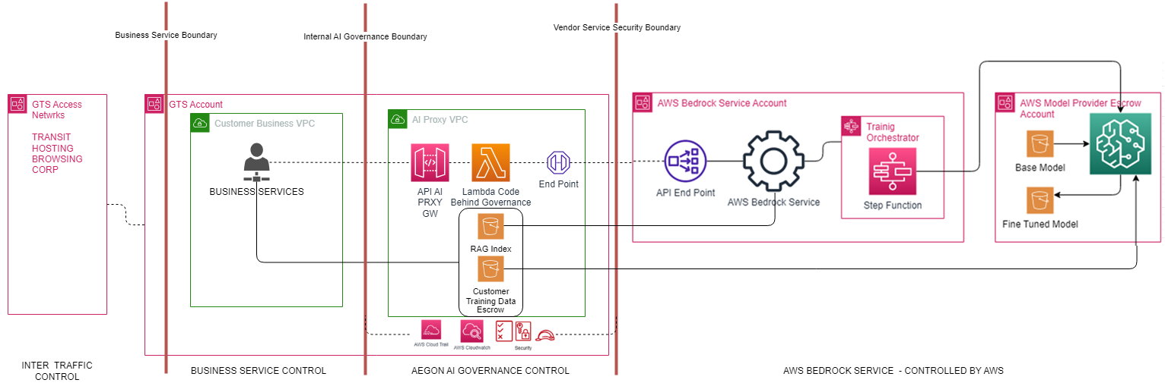
The model shows 4 key domains - each network has a specific role in ensuring proper management of all AI Services. They are:
- AWS Bedrock Service: the infrastructure defined in this domain isolates the AWS Bedrock Service. Access to this domain can only be gained by passing through the Aegon Governance Control network.
- Aegon Governance Control: ensures that the service is used in line with the AI Governance Policy for that Business Unit – this will also be the boundary that will host the Bedrock Agent.
- Business Service Control: ensures that only allowed services defined by the unit can gain access to the AI Service and then only through the Governance Control network.
- Inter Traffic Control: ensure that only allowed traffic is allowed access to the business services.
Note the split between domains 2 and 3 are further detailed in the operational deployment model section.
separated by 3 security boundaries:
- Vendor Service Boundary: this ensure that only traffic/roles from the AI Governance Boundary can get access to the Bedrock Service (Vendor)
- AI Governance Boundary: this ensures that only traffic/roles from the Business Service can get access to the AI Governance Boundary
- Business Service Boundary: this controls what traffic/roles from the wider enterprise can get access to the Business Services.

AWS BEDROCK Service
- Amazon Bedrock is serverless, you don't have to manage any infrastructure, and you can securely integrate and deploy generative AI capabilities into your applications using the AWS services you are already familiar with. The service itself is a multi-tenanted service within the AWS Ecosystem. AWS uses logical isolation techniques as part of their core platform to ensure each customers organization are kept separate.
The architecture shows the customer accounts - these will be GTS Accounts. The customer accounts are there to
  - Host the any services that wants to access AWS Bedrock Model.
  - Provide Training Data so that we can fine tune the base models.
AWS BEDROCK Agents
- Agents for Bedrock streamline workflows and automate repetitive tasks. These are deployed within the managed AWS Managed Accounts and accessible through relevant API calls.
AEGON AI Governance Controls
- API Gateway provides the proxy gateway that provides the API that can be readily used by allowed business services.
- Code Behind Governance Lambda, provides the governance logic that can be applied to all request and responses so that the business can control all aspects of use. This layer a air gap between what the business service asks and what the AI models receives and what the AI Model provides and what the Business Service receives - how much adaption we place here will be in the level of control the business need to apply against each operational concern.
- Escrow Databases allows for an Escrow style capability where the business can upload their data to safe environment so it can be processed effectively so that it can be used to either -
  - fine Tune a Based Model to a Custom Model
  - be used for Retrieval Augmented Generation
BUSINESS Service Controls
- The is the standard business service domains that exist today. The services can exist anywhere in our landscape and can interact with any GEN AI service/agent as long as it has the correct security authorization and authentication to do so.
INTER Traffic Control
- This is the standard transit network that will connect a business service account to all other parts of Aegon enterprise. All internal account traffic will happen across the AWS backbone.
Service Activation
- The service will only be activated on the AEGON AI GTS managed accounts for Production. BU’s will be allowed to enable this in non-production accounts as part of their development activity. This will ensure that the correct centralized controls and guardrails will be enforced. Please refer to the three operational deployment models in later section.

Enterprise Fit
As AWS Bedrock is part of a suite of AWS managed services we already have a model for integrating with our enterprise landscape, there is little new integration effort required to bring it in to our portfolio of secured capabilities. The model below replays the fit within the context of AWS Bedrock and AWS Bedrock Agents and out SSO environment.
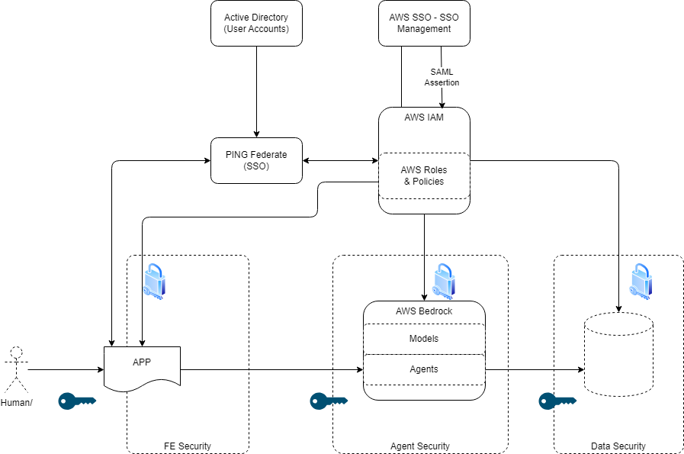

Driver
AWS Bedrock provide a serverless capability to fine tune several foundational models with our own business data. Creating custom models in this way allows us to leverage the capability of these base models with the benefits of having them tuned to our functional domains., reducing costs and time in provisioning this capability to services. The service comes with a base set of models that can be customized they are:
- Amazon Titan:
  - Use Titan Text for creating copy for blog posts and web pages, classifying articles into categories, open-ended Q&A, and information extraction.
  - Get the gist of lengthy documents of text, such as reports and even books, with summaries based on natural language prompts.
  - Use Titan Embeddings for applications like personalization and search. By comparing embeddings, the model can produce more relevant and contextual responses than word matching.
  - Deliver more up-to-date and accurate results for user queries by connecting FMs to your data sources.
- Claude
  - Claude can act as an always-on virtual sales representative, ensure speedy and friendly resolution to service requests, and increase customer satisfaction.
  - Claude can extract relevant information from business emails and documents, categorize and summarize survey responses, and wrangle reams of text with high speed and accuracy.
  - Claude can parse legal documents and answer questions about them, so lawyers can reduce costs and focus on higher-level work.
  - Claude models are constantly improving on coding, math, and reasoning. The latest model Claude 2 scored 71.2% (up from 56.0%) on the Codex HumanEval, a Python coding test.
- Command
  - Enables apps like knowledge assistants and customer support chatbots with seamless and dynamic user experiences that maintain conversational context.
  - Builds articles, product descriptions, and more based on user prompts.
  - Summarizes key ideas and themes from diverse long-form text, such as news, investor reports, legal, or medical information.
- Jurassic:
  - Condense financial reports into bite-sized summaries, extract key data from documents, and generate financial and legal statements tailored to specific needs and requirements.
  - Generate product descriptions, summarize, and analyze product reviews, and craft bespoke marketing content according to your desired tone, length, and style.
  - Provide customers with instant, natural language responses to inquiries based on documents, policies, and info sheets.
  - Make it easy for employees to access organizational data and extract insights using natural language.
- Llama2 (Coming Soon)
  - Meta's fine-tuned LLMs, called Llama-2-Chat, are optimized for dialogue use cases.
The service provides the capability to fine tune each of these models using your own data to create custom models. Each of these enablement will have all appropriate guardrails applied as part of the central service deployment - see operational deployment models

Value
- Holistic Decision Making:
  - An AGI can process vast amounts of financial data from diverse sources to make informed decisions. It can analyze market trends, historical data, news, geopolitical events, and more to provide insights that are beyond the scope of narrow AI systems.
- Personalized Financial Products:
  - AGI can understand individual customer profiles in depth, allowing for the creation of highly personalized financial products tailored to each customer's needs, preferences, and risk appetite.
- Advanced Fraud Detection:
  - While current AI models can detect fraudulent patterns based on historical data, an AGI could adapt and learn in real-time from new, unknown fraudulent techniques, offering a dynamic defense mechanism.
- Automated Financial Advisory:
  - With its broad understanding, AGI could serve as an all-in-one financial advisor, tax consultant, and retirement planner, providing comprehensive advice to clients.
- Operational Efficiency:
  - An AGI could oversee multiple operational areas simultaneously, from risk management to customer service to trading operations, optimizing processes across the board.
- Real-time Risk Assessment:
  - AGI can dynamically assess and respond to various financial risks, adapting its strategies in real-time as market conditions change.
- Enhanced Customer Service:
  - Beyond answering queries, an AGI-powered customer service system could proactively address customer needs, predict issues, and offer solutions before they escalate.
- Regulatory Compliance:
  - Financial regulations are complex and ever-changing. AGI could ensure that the company remains compliant by continuously monitoring regulatory changes and adjusting operations accordingly.
- Strategic Planning and Forecasting:
  - AGI's ability to process vast amounts of diverse data could lead to more accurate financial forecasts and strategic plans.
- Cost Efficiency:
  - With its ability to handle multiple tasks adeptly, AGI could reduce the need for specialized systems or tools, leading to cost savings.
Why is it required?
- Competitive Advantage:
  - As financial markets become more dynamic and competitive, companies that leverage advanced technologies like AGI could gain a significant edge over their competitors.
- Meeting Customer Expectations:
  - The modern customer expects personalized, efficient, and advanced financial services. AGI can help meet and exceed these expectations.
- Handling Complex Financial Ecosystems:
  - The financial world is becoming increasingly interconnected and complex. AGI's ability to understand and navigate this complexity can be invaluable.
- Safety and Security:
  - With rising cyber threats and fraud, having an advanced system like AGI that can dynamically adapt and defend against new threats can be crucial.
- Regulatory Pressure:
  - Regulatory bodies are putting more emphasis on transparency, customer protection, and risk management. AGI can help financial institutions stay ahead of these requirements.
- Efficiency and Growth:
  - For sustained growth and efficiency, financial institutions need to constantly innovate and optimize. AGI offers a pathway to achieve this by automating and enhancing various processes.

Considerations
With a view to the Azure and AWS Well Architected Frameworks, consider how the component should be configured under the following contexts.

Security
  - AWS: AWS advocates a multi-layered security approach, integrating identity and access management, network security, and encryption. AWS Identity and Access Management (IAM) is at the heart of its identity services, offering multi-factor authentication and fine-grained access control. AWS also offers tools like AWS Security Hub for consolidated security management.
  - Architecture: The architecture in this standard ensures the right balance of isolation between compute and data. This ensures that individual services can be configured to support various levels of granularity, ensuring that processed data and utilized compute resources are safeguarded effectively.

Cost Optimization
  - AWS: AWS Cost Explorer allows users to visualize and manage their AWS costs and usage over time. AWS Trusted Advisor also offers insights to help users reduce costs and optimize AWS resources.
  - Architecture: The architecture has been designed with cost allocation in mind. The configuration of the AWS resource groups, the metadata associated with each infrastructure component, and the real-time costing of all requests and responses provide detailed real-time insights and cost allocation.

Operational Excellence
  - AWS: AWS emphasizes continuous refinement of operational practices. AWS CloudWatch and AWS X-Ray offer comprehensive monitoring, advanced analytics, and smart alerting.
  - Architecture: The architecture fully leverages serverless infrastructure and supports comprehensive monitoring and logging, integrating seamlessly into the broader operational environment.

Reliability
  - AWS: AWS ensures high availability and resilience through services like Amazon Route 53 (for DNS-level traffic routing) and AWS Backup (for backup and restore capabilities).
  - Architecture: The architecture takes full advantage of serverless infrastructure, scaling automatically to meet a base level of Service Level Objectives (SLOs), including service resilience, data backup, and recovery.

Performance Efficiency
  - AWS: AWS suggests using services like Amazon CloudFront (CDN) to decrease load times and conserve bandwidth. AWS also provides a variety of EC2 instance types to cater to the specific requirements of an application.
  - Architecture: The architecture incorporates the capability to enable caching mechanisms in crucial service areas where repetitive data is requested, enhancing speed and minimizing compute costs.

Sustainability
  - AWS: AWS's sustainability approach includes initiatives for renewable energy, water usage efficiency, and sustainable buildings. AWS is also committed to achieving 100% renewable energy usage for its global infrastructure.
  - Architecture: The architecture aims to ensure minimal computational cycles, reducing the compute and data footprint associated with using this service/standard.

Functionality / How it Works
Define the functionality of the component. This includes the component's purpose, its inputs and outputs, and its behavior. The functionality should be clear and concise. It must be easily understood by architects, developers, and business users.
Highlight the main use cases – full details are in a later section.
Component | Purpose | Inputs/Outputs | Behaviour
AWS Account | There are 3 classes of account.  - Escrow: this is a safe place to tune foundational models for your own use it's a place where 3rd parties can provide foundational models but have no access to the models once deployed and have no access to your custom models.  - Bedrock Service Account provides the mechanism to allow the customer to execute the configuration and execution of their custom models and making them available for use.  - Customer Account. provides the space for the customer to create their personalize services and proxies that will make use of AWS Bedrock - it also allows the customer to make available data to escrow for custom model creation. | REST Request/Response Structures | The 3 accounts provide isolated boundaries to ensure that the customers models and data are properly secured, whilst ensuring that AWS Bedrock can effectively operate under the customers direction and where AWS Partners can provide foundational models.
Step Functions | Provides flow control to ensure that the correct process in executed when the customer generates custom models. | REST Request/Response Structures | Event driven workflow that can be configured to support multiple actions as part of a complex workflow driven through the AWS Bedrock Service User interface and API's.
AWS Bedrock Service | Provides a user interface and workbench along with APIS that provides the human and programmatic interactions to the service. | REST Request/Response Structures & UI | Provides the Services interfaces so that users can effectively use the service,
Private End Points | These ensure that all traffic stays within the AWS account. | HTTPS | restricts any traffic going out through the internet and staying within the boundary and control of the customer's account.
Please use this link to get an overview of the components

Architectural Attributes

Interfaces
The link takes you to the official API documentation for the core service.
- Please look at the Architecture Pattern (below) on how to proxy these services.
  - We must not access these API's directly
  - We must not make these API's publicly accessible.

Redundancy, Availability & Reliability
The link takes you to the SLA model for all the services on the AWS cloud. How this may need to be configured will depend on the use case being solved for.

Scale, Elasticity & Capacity
Amazon Bedrock is available in US East (N. Virginia) and US West (Oregon) and will be available in additional AWS Regions soon.
Quotas for Amazon Bedrock - Amazon Bedrock

Cost, Business & Support Models
Pricing Models : Please see the Amazon Bedrock Pricing Page for current pricing information.
Support Models : Depending on your AWS support contract, Amazon Bedrock is supported under Developer Support, Business Support and Enterprise Support plans.

User Access & Roles
Define the users and roles that are required to use the component in a compliant manner.
Emphasize the use of fine-grained security controls and separation of concerns.

Federated Roles & Access Control Policies
Each unit may look to have their own variations on these roles to ensure the correct separation of concerns. Each unit looking to make use of the AWS Bedrock Service should have an agreed RACI with GTS for each use case they look to deliver against the service.

Role | Purpose | Security | Access Profile
General User | Someone that can use the service | UAI-[SRV]-[UNIT]-[DEPT] | The SRV will be a 3 letter abbreviation for the service and can be extended to the Unit and Department.
Custom Model Data Scientist/Engineer | Responsible for creating and release customer models for business use. | CMDL- Model Engineer | Upload Data  Train Models  Deploy to Library  Access to Playground
Proxy API Designer/Developer | Responsible for developing Proxy API and code behind services that provide the correct Pre and Post processing of requests and response from core service. | PRXYAPI - Proxy Engineer | Design, Build, Deploy API's including code behind services for pre and post processing of the request and response.  Access to Playground  Access to API's
RAG Data Analyst/Engineer | Responsible for adding and indexing external data sources so they can be configured to be used against any of the models. | RAGD - RAG Engineer | Source, index and enable and catalogue data indexes that can be deployed with the models.  Access to Playground  Access to API's
Data Pipeline Engineer | Responsible for the automation the business services being enabled to ensure a consistent execution and delivery of all capabilities as part of the business enablement. | DPIP - Pipeline Engineer | Build automation of all engineering and operational concerns in addition to tie in with the enterprise pipelines and ensure that appropriate quality gates are met as agreed with the service architect.  Access to API's
Model Librarian | Responsible for curating models and their enablement. | MLIB - Model Librarian | Access to the service to maintain the library and analytics around model use, making recommendation for new models and removing old models. Managed the meta data around the models to that they are readily searchable.  Access to Playground  Access to API's
Service Analyst | Responsible for ensuring that the service is delivering against business goals out lined as part of the service value. This includes model accuracy and observing model drift. | SANLYT - Service Analyst | Access to the data that is generated around the service so that the appropriate insights can be communicated to the business unit.  Access to Playground  Access to API's  Access to Data
Service Architect | Responsible for the alignment with the standards and ensures that the service is fit for purpose against the capability model, the functional and non functional requirements for this service within the deployment instance. | SARCH - Service Architect | Access t the Playground

Restrictions
As a managed service provide by AWS Bedrock physical runs in AWS Managed Account, we get access to a tenancy in this environment when we enable the service. Guardrails for the service govern several control aspects. Thes guardrails will be set centrally for non production environments from the central GTS AI Account – see operational deployment models
- Prompt, Response, Knowledge base evaluations.
- Access to managed 3rd Party LLM Models
- Configure thresholds on filters and harmful content.
- Define and disallow certain topics and language.
- Removal of PII and other restricted data
- Filter out hallucinations based on context and grounded ness.

Enterprise - access to AWS Bedrock will always be through a centralized account.

Permitted Regions
The deployment of AWS Bedrock will be at account level and be accessible from each of the allowed standard regions.

Operational Deployment Models

The models below describe the 3 operational deployment configurations that will be allowed as part of this service enablement in the landscape. Particular attention should be made to the static position of those components that are AWS Bedrock Components (outlined in purple). The other components show the wider infrastructure that will be part of the deployment to support a controlled use of the service within the environment.

Also note across all three models there will be a central interface before accessing the AWS Bedrock Service itself.

Centralized Model
– so called, as all of the orchestration (workflow), is operated from a central account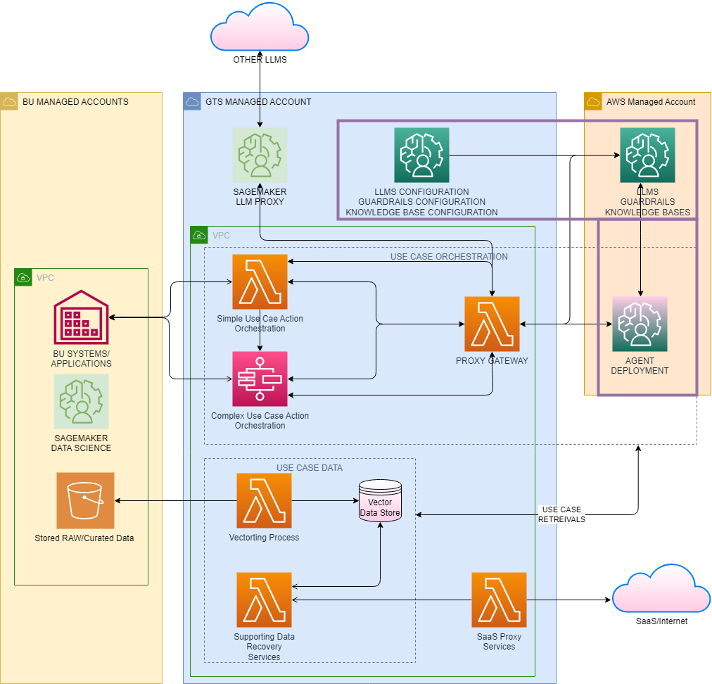

Note the thin blue line

Federated Model
– so called as some of the orchestration is split between BU and Central accounts 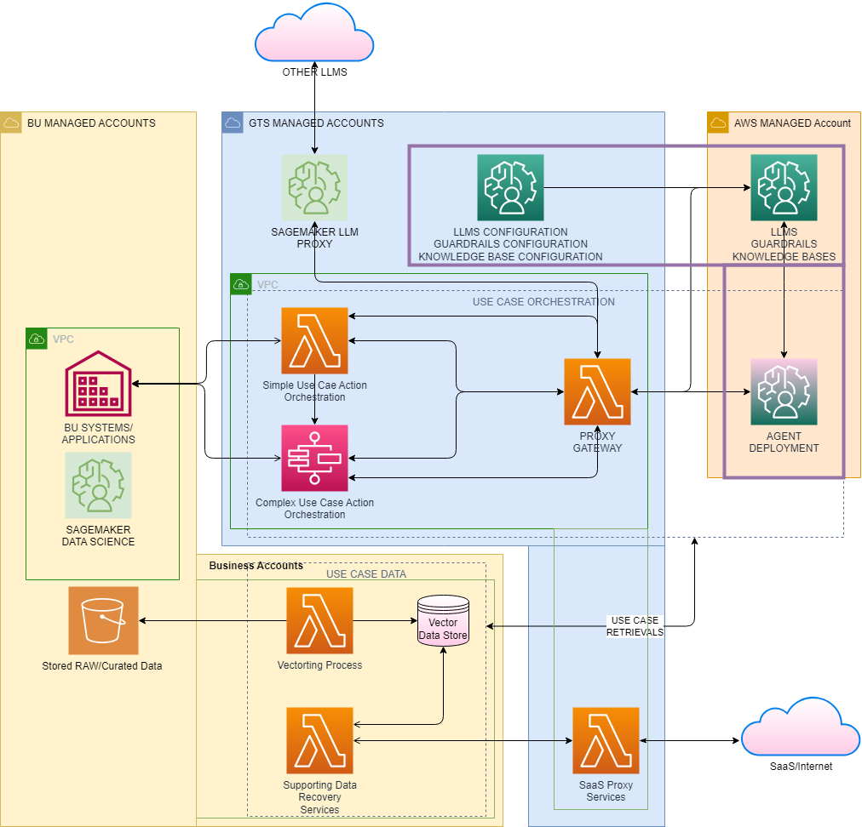

Note the thin blue line

Federated + Model
– so called as the orchestration is extensively held in the BU Accounts.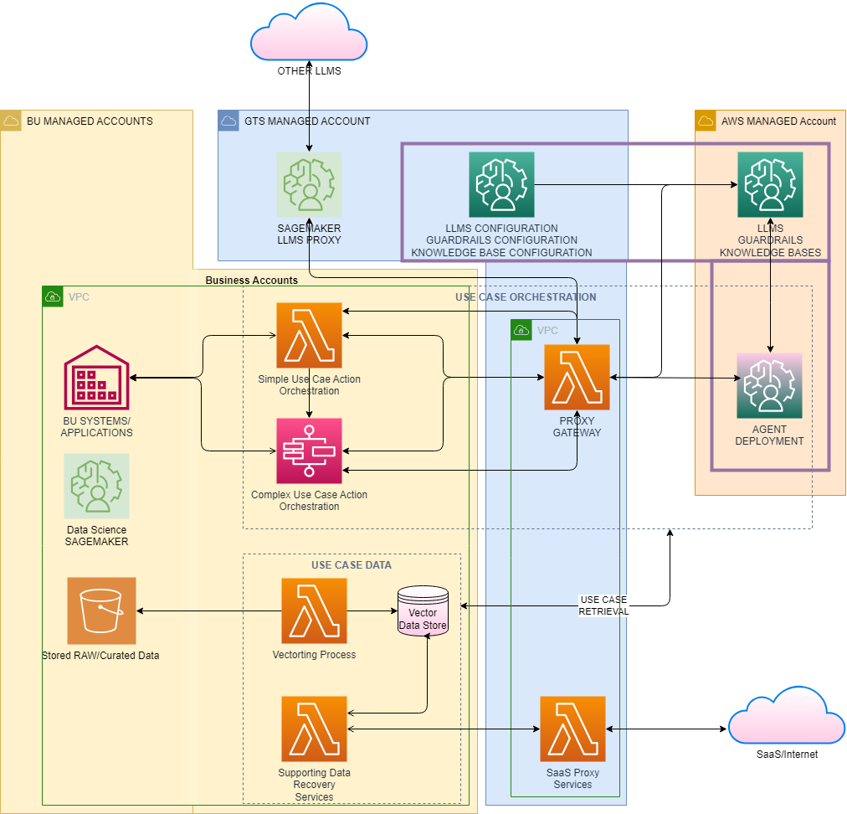

Note the thin blue line

Thin Blue Line
This is the name of the control layer that ensured that all production depolyment use the centralized instance of AWS Bedrock, ensuring that all consuming services are controlled by the same guardrails and governance logic that we as an organization develop and enforce. The control layer will be deployed through a managed pipeline that can only be run under a specific control role. Although this is not part of the AWS Bedrock Service it will be part of the wider service and operational enablement of this service in the landscape ensuring central governance.

Security Control Polices
The AWS security control polices can be defined so that only AWS Bedrock is deployed into BU Non-Prod Accounts only and all accounts that are for GTS AI Accounts. SCP application can be carried out against any level of account tagging. For this purpose we are keeping it to the table
Deployment | Allowed Environments | Disallowed Environments
BU AWS Accounts | Non Prod Account | Prod Accounts
GTS AI Accounts | All AI Accounts | None

Risk and Concerns
In Aegon the AWS Org has two different types of Organizational Unit – Non Prod and Production. Non Production covers 4 different environments Engineering Acceptance Test (EAT), Development (Dev), Test (Tst) and Model (mdl). Production covers a single environment Production (Prd). The concerns are around misuse of the service in non-production in such a way that when it comes to deploying into production the service is no capable as the non-production configurations are not allowed.

Mitigation Options
  - Move Model to Production OU so that we hit the restrictions earlier in the delivery lifecycle.
    - This will have a massive impacted on the landscape, and would take a long time to implement and enforce.
  - Employ a mix of governance and landscape enablement to ensure that Non Production Deployments will reflect Production.
    - This has been agreed with the business units and comes in two levels of control
    - Usecase feasibility assessment at the beginning of any Use Case proposal. This will outline the components that will be required to be developed/configured and by whom and will define the path to production and the various steps to ensure correct delivery
    - Enablement of the ‘thin blue line’ control pipeline to ensure that what teams get in their non prod accounts are reflective of what they will get in the prod accounts.

Feasibility Assessment & ARB:
the model below shows how the feasibility assements fits into the ARB. When a GEN AI use case is assessed a bill of materials is created – this will defined how the use case will be solved and the components and models that will be required to solve the use case. The assessment will defined what needs to go to the ARB and what controls need to be assigned. It is as this time we will understand the required change in the current control position. Any changes will be assessed for ARB Approval. At this time of approval we will be able to make the changes to the thin blue line.

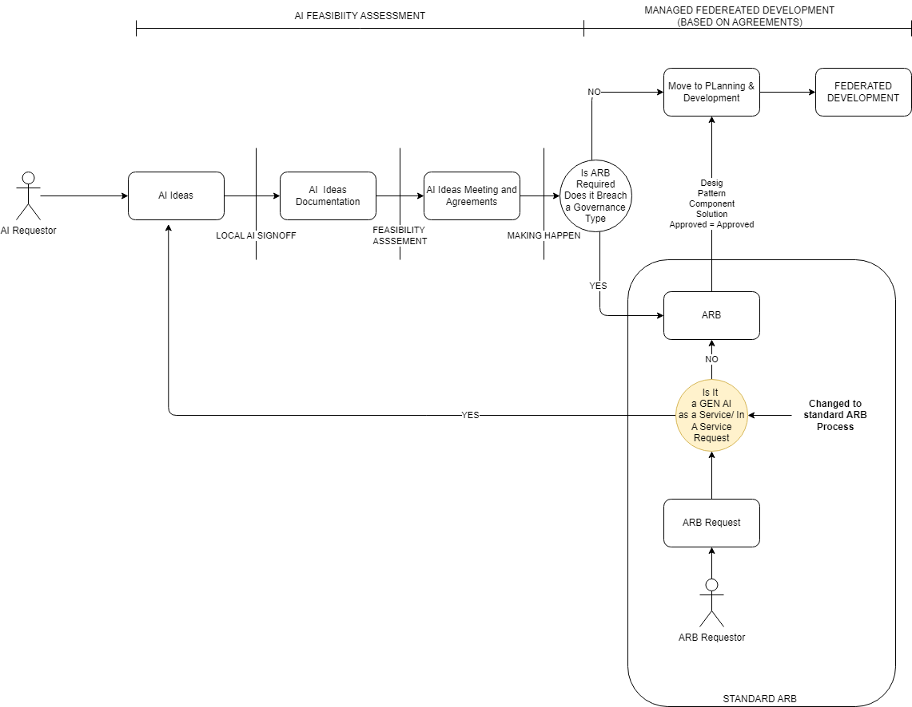

Consistency through the landscape ( the thin blue line):
these controls will be deployed as a separate pipeline that will inflate the appropriate proxy infrastructure that will ensure that access to the AWS Bedrock Service and Models are controlled. This proxy infrastructure will allow Aegon to deploy the correct logging and observations as required to all LLM requests before sending to LLM. To ensure consistency in all environment this pipeline will be capable of being run in NON Prod environments – this will allow all service development teams to test there service against the production control layer controls before moving to production. These pipelines will be held in a central repo available to be used by all units.
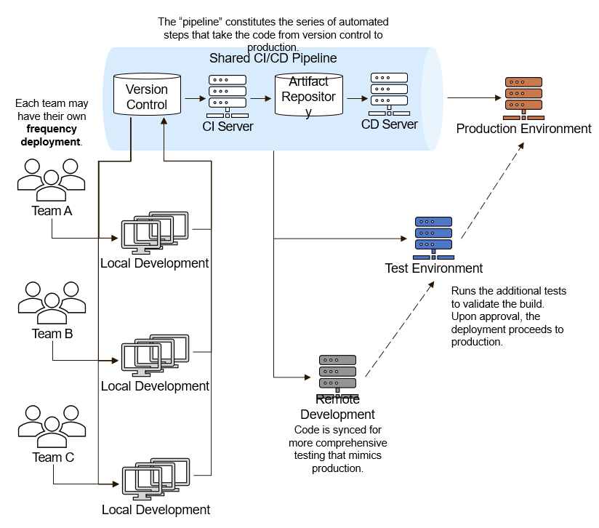
The pipeline will make it easy for Business units to deploy the same proxy controls in non prod accounts to ensure compliance before they release their service into the production accounts that will enforce this centralized governance.

Business Unit Use Cases Operations
The three operational models show the operational instances to which any business unit can operate with AWS Bedrock under. These models will allow the support of all Business GEN AI Use Case. There will be no need to support any other Business Unit deployment of AWS Bedrock, out with these operational models.

Note: other LLMS and Internet Access will be accommodate through the GTS Managed Account ensuring that we minimize the proliferation of common and core services, maximizing reuse and minimizing cost, within our current operational landscape

Use Cases
These are just a few examples. The adaptability of GEN AI means that its potential applications within a Financial Service Organization and ITSM can be vast and continually evolving. As with any AI implementation in the financial sector, it's essential to ensure that the technology is used ethically, transparently, and with a clear understanding of its limitations
- Customer Support:
  - Chatbots and Virtual Assistants: GEN AI can provide more nuanced and context-aware responses to customer queries, resulting in a more human-like interaction experience.
  - Automated Ticketing: Resolve common IT issues without human intervention by generating solutions or workflows for reported problems.
- Fraud Detection and Prevention:
  - Anomaly Detection: GEN AI can be used to model regular transaction patterns and subsequently identify anomalies that may indicate fraudulent activities.
  - Narrative Generation: Produce human-readable explanations of potentially suspicious activities for review by risk management teams.
- Personalized Banking:
  - Financial Advice: Generate personalized investment strategies or saving advice for clients.
  - Tailored Product Recommendations: Suggest financial products or services tailored to individual customer profiles and historical data.
- Document Automation:
  - Report Generation: Automatically generate financial reports, summaries, or analyses based on data.
  - Contract and Document Creation: Generate drafts of standard contracts or other documents based on specific input parameters.
- Operational Efficiency in ITSM:
  - Incident Reports: Automatically generate detailed incident reports based on system logs and user inputs.
  - Predictive Maintenance: Predict IT infrastructure issues and generate solutions before they escalate.
- Knowledge Management:
  - Knowledge Base Augmentation: Automatically generate FAQs or knowledge base articles based on recurrent issues or new products.
  - Search Enhancement: Improve internal search functionalities by generating context-aware responses or guiding users to relevant documentation.
- Risk Management:
  - Scenario Analysis: Generate potential financial or market scenarios for stress testing or risk modeling.
  - Communication: Generate tailored communications for different stakeholder groups based on emerging risks or issues.
- Market Analysis and Research:
  - News Summarization: Provide concise summaries of financial news, research, or market trends.
  - Sentiment Analysis: Extract and generate insights from vast amounts of data, such as news articles, financial reports, or social media, to gauge market sentiment.
- Training and Onboarding:
  - Interactive Training Modules: Create dynamic training content that responds to the learner's inputs and queries.
  - Onboarding Processes: Simplify onboarding by generating personalized information packets or guides for new hires.
- Regulatory Compliance:
  - Regulation Monitoring: Keep track of and generate summaries of new financial regulations or guidelines.
  - Compliance Reports: Generate compliance reports tailored to specific regulatory requirements.

Data & Governance
Define the data that is used by each component. This includes the data's format, its location, and its security requirements. The data should be defined in a way that is consistent with the overall architecture, and that allows data to be easily shared between components.
Amazon Bedrock offers several capabilities to support security and privacy requirements and is compatible with common compliance standards including GDPR and HIPAA. As with all AWS services, you get the standard AWS Identity and Access Management (IAM) controls for authentication and AWS CloudTrail for auditing API activity. All your data is encrypted at rest using your own AWS Key Management Service (AWS KMS) keys, which provides full control and visibility into how your data and custom models are being stored and accessed. With PrivateLink, you can pass your data on AWS to Amazon Bedrock exclusively through AWS and never through public internet. Amazon Bedrock can also attach its training instances to your Amazon VPC in order to read from and write data to Amazon S3.
With Amazon Bedrock, you can privately customize FMs, retaining control over how your data is used and encrypted. Amazon Bedrock makes a separate copy of the base foundational model and trains this private copy of the model. Your data including prompts, information used to supplement a prompt, FM responses, and customized FMs remain in the Region where the API call is processed.
When you use Amazon Bedrock to customize a model, Amazon Bedrock can fine-tune the model for a particular task without having to annotate large volumes of data. Then, Amazon Bedrock makes a separate copy of the base foundation model that is accessible only by you and trains this private copy of the model. None of your content is used to train the original base models. You can configure your Amazon VPC settings to access Amazon Bedrock APIs and provide model fine-tuning data in a secure manner. Your data is encrypted in transit (TLS1.2) and at rest through service-managed keys.
Any customer content processed by Amazon Bedrock is encrypted and stored at rest in the AWS Region where you are using Amazon Bedrock.

Component | Data Used | Highest Class of Data | Security Requirement
Models | Any Class | Strictly Confidential | The user must only have access to data that is in their class. Mechanisms should be deployed that can declassify data for ore generic use.
API | Any Class | Strictly Confidential | The user must only have access to data that is in their class. Mechanisms should be deployed that can declassify data for ore generic use.  Request and Responses should be assed for class and the contents of request and response should align to the classification allowed to be operated upon by the users/system process.

Data Classification
Refer to the ITCF Framework and ICTF P04.01.02 Information Security Classification Standard for guidance on data classification the controls for processing, storing and transmitting data.
- Public: Can be used to transfer public files, such as marketing materials or product documentation.
- Internal: Can be used to transfer internal files, such as personal information in a defined context or operational guidelines.
- Confidential: Can be used to transfer sensitive files, such as personal information related to employees, business/marketing plans.
- Strictly Confidential: Can be used to transfer very sensitive files, such as healthcare data or government classified information, trade secrets, strategic plans.
  - PII: Can be used to transfer personally identifiable information (PII), such as names, addresses, and Social Security numbers.
  - HIPAA: Is HIPAA eligible, meaning it can be used to transfer healthcare data in compliance with the Health Insurance Portability and Accountability Act (HIPAA).
List any guidelines/restrictions for use of specific data classifications.

Guardrails
Amazon Bedrock offers comprehensive monitoring and logging capabilities that can support your governance and audit requirements. You can use Amazon CloudWatch to track usage metrics and build customized dashboards with metrics that are required for your audit purposes. Additionally, you can use AWS CloudTrail to monitor API activity and troubleshoot issues as you integrate other systems into your generative AI applications. You can also choose to store the metadata, requests, and responses in your Amazon Simple Storage Service (Amazon S3) bucket. Lastly, to prevent potential misuse, Amazon Bedrock implements automated abuse detection mechanisms.
Guardrails are essential to ensure that the technology is used responsibly, ethically, and efficiently. Here are some crucial guardrails to be consider, each deployment should support an auditable document which prescribes a position against each of these:
Data Privacy and Security:
Ensure that personal and sensitive data is anonymized or masked, especially during model training.
- Data Masking/Anonymization: Use AWS Lambda to create serverless functions that process and mask data before storage or use.
Implement strict controls on who can access the AI system, the data, and the generated outputs.
- Access Controls: Utilize AWS Identity and Access Management (IAM) to define roles and permissions.
Ensure data is encrypted both at rest and in transit.
- Data Encryption: Use AWS Key Management Service (KMS) for encryption keys and enable encryption on Amazon S3 buckets and Amazon RDS databases.

Transparency and Explainability:
Use tools that can help in explaining the AI's decisions, especially in high-stakes scenarios.
- Interpretability Tools: Integrate with tools like AWS SageMaker Clarify to provide insights into model decisions.
Maintain comprehensive documentation on how the AI system works, its training data, and its decision-making processes.
- Documentation: Store documentation Sharepoint

Bias Detection and Mitigation:
Regularly audit models to identify and correct biases.
- Bias Audits: Use AWS SageMaker Clarify for bias detection during model training.
Ensure the training data is representative and does not favor any particular group.
- Diverse Training Data: Store diverse datasets in Amazon S3 and use AWS Glue for data cataloging.

Continuous Monitoring and Feedback:
Continuously monitor the AI's performance using relevant metrics to ensure it's meeting its objectives.
- Performance Metrics: Monitor with Amazon CloudWatch and AWS SageMaker Model Monitor.
Implement mechanisms for users to provide feedback, and ensure there's a process to act on this feedback.
- Feedback Loops: Implement feedback collection using Amazon API Gateway and store feedback in Amazon DynamoDB.

Regulatory Compliance:
Ensure the AI's operations comply with financial regulations, especially concerning automated decision-making and data handling.
- Regulatory Alignment: Use AWS Config for continuous monitoring and compliance checks.
Maintain comprehensive logs of all AI activities to support audits and regulatory reviews.
- Audit Trails: Enable AWS CloudTrail for logging all API calls and activities.

Operational Resilience:
Have backup processes in place in case the AI system fails or provides unreliable outputs.
- Fallback Mechanisms: Use AWS Lambda for event-driven fallback processes.
Update the AI models regularly to accommodate changes in data patterns and financial market dynamics.
- Regular Updates: Automate model updates using AWS SageMaker Pipelines.

Stakeholder Engagement:
Ensure that employees understand how the AI system works, its benefits, and limitations.
- Training: Host training materials on sharepoint
Clearly communicate to customers when and how AI is being used, especially in decision-making processes.
- Clear Communication: Use Amazon Simple Notification Service (SNS) for notifications and communications.

Model Validation and Testing:
Before deployment, the model should undergo rigorous testing to ensure it's reliable under various scenarios.
- Robust Testing: Use AWS SageMaker for model training and testing.
Maintain version histories of models to roll back if newer versions display unexpected behavior.
- Version Control: Implement version control using GitHub.

Ethical Considerations:
Establish clear ethical guidelines on AI usage, especially concerning data usage and decision-making.
- Ethical Guidelines: Store guidelines on Sharepoint for collaboration.
Regularly assess the societal and ethical impacts of the AI system, including its effects on employment.
- Impact Assessments: Use AWS Lambda and Amazon Athena for regular assessments.

Human-in-the-loop (HITL):
Especially during initial deployment, ensure that human experts oversee the AI's decisions.
- Supervised Operations: Integrate human reviewers using Amazon Augmented AI (A2I) [we would need to take this through ARB] or any manual process.
Implement mechanisms for human experts to review and, if necessary, override AI-generated decisions.
- Review and Override: Use AWS Step Functions to create review workflows.

Limit Scope of Autonomy:
Set clear boundaries on what the AI can and cannot do autonomously. For critical decisions, a human approval step might be necessary.
- Defined Boundaries: Implement boundary checks using AWS Lambda and store rules in Amazon DynamoDB.

Disaster Recovery and Contingency Planning:
Ensure there are backup systems in place to restore operations in the event of failures.
- Backup Systems: Use Amazon S3 versioning and cross-region replication for backups.
Prepare for different scenarios, including data breaches, system malfunctions, and regulatory challenges.
- Scenario Planning: Utilize AWS Organizations for account structuring and AWS Shield for DDoS protection.
By putting these guardrails in place, a financial organization can mitigate many of the risks associated with implementing GEN AI, ensuring that the technology is used effectively, ethically, and responsibly.

Product / Component Selection
When to use, or not use this component. Include references to alternative components if possible. Here's a set of criteria to consider when determining the appropriateness of GEN AI deployment:
- Task Suitability:
  - Complexity: Is the task complex enough that traditional algorithms are insufficient or inefficient?
  - Variability: Does the task require handling diverse inputs or producing diverse outputs?
  - Scalability: Is there a need to handle large volumes of data or high query rates where automation can be beneficial?
- Data Availability:
  - Volume: Is there enough data available to train or fine-tune the AI model effectively?
  - Quality: Is the data clean, well-structured, and free from biases?
  - Relevance: Is the data relevant to the task at hand, and does it capture the nuances of the financial sector?
- Business Impact:
  - Value Proposition: Will GEN AI bring tangible benefits, such as increased efficiency, better customer service, or reduced operational costs?
  - Risk Profile: Can the risks (e.g., making incorrect predictions or recommendations) be managed or are they outweighed by potential benefits?
- Regulatory and Compliance Considerations:
  - Transparency: Can the AI model's decisions be explained or interpreted, especially when required by regulators?
  - Accountability: Is it clear who is responsible if the AI makes an error or if there's a system malfunction?
  - Data Privacy: Does the AI deployment adhere to data protection regulations, such as GDPR or CCPA?
- Technical Infrastructure:
  - Integration: Can the GEN AI be integrated seamlessly into the existing IT infrastructure without causing disruptions?
  - Maintenance: Does the organization have the technical expertise to maintain, update, and troubleshoot the AI system?
  - Security: Can the organization ensure the security of the AI system to prevent data breaches or unauthorized access?
- Ethical Implications:
  - Bias and Fairness: Does the organization have measures to ensure that the AI system doesn't perpetuate or introduce biases?
  - Impact on Employment: How will the introduction of GEN AI impact employees? Is there a plan for retraining or upskilling?
  - Transparency with Customers: Are customers informed about how and when AI is used, especially in decision-making processes that affect them?
- Cost-Benefit Analysis:
  - Return on Investment (ROI): Will the investment in GEN AI (including development, integration, and maintenance costs) yield a positive return in the foreseeable future?
  - Long-term Viability: Is the AI solution scalable and adaptable to future business needs and challenges?
- Stakeholder Acceptance:
  - Internal: Are employees, especially those directly affected, on board with the introduction of GEN AI? Is there buy-in from leadership?
  - External: Are customers, partners, and other stakeholders comfortable with the organization's use of GEN AI? Is there a communication strategy in place?
Before deploying GEN AI, it's also beneficial to conduct pilot projects or proof-of-concept initiatives to gauge its effectiveness and suitability for the particular financial context. Proper due diligence, combined with continuous monitoring and feedback loops, will ensure that GEN AI is employed optimally and ethically.

Feature Comparison
Preferably a table of features in the same component-class, identifying key features, advantages and disadvantages based on the Architectural Attributes above.

Exceptions
GEN AI, as powerful as it is, isn't always the right solution for every challenge faced by financial organizations. Here are situations where GEN AI might not be appropriate:
- High-Risk Decision Making: In scenarios where the stakes are high, and errors could result in significant financial, reputational, or legal repercussions, relying solely on GEN AI might be too risky. Examples include high-value investment decisions, approval of large loans, and critical risk assessments.
- Where Interpretability is Paramount: GEN AI, especially deep learning models, can be "black boxes," making it challenging to interpret their reasoning. In regulatory environments where decisions need to be clearly explained, more interpretable models or human oversight may be required.
- Limited Data Availability: Effective deployment of GEN AI often requires substantial, high-quality data. In scenarios where there's limited or unreliable data, using GEN AI might not be ideal as it can lead to inaccurate or biased outputs.
- Sensitive Personal Data Handling: If a task involves the direct processing of highly sensitive personal data, relying on AI, especially cloud-based solutions, might pose privacy risks. Human intervention, strict data masking, or on-premises solutions might be more appropriate.
- Tasks Requiring Human Intuition or Emotion: Some financial decisions benefit from human intuition, experience, and emotional understanding, such as handling sensitive customer complaints or personal financial counseling. GEN AI isn't adept at capturing human emotional nuance.
- Regulatory Prohibitions: In certain jurisdictions or for particular financial products, there may be explicit regulatory prohibitions or limitations on using AI for decision-making. Always ensure compliance with local regulations.
- Frequent Context Shifts: If the business environment or data patterns shift frequently and unpredictably, GEN AI models that require consistent data patterns may struggle and need constant retraining.
- Cost Concerns: Training and deploying sophisticated GEN AI models can be resource-intensive. If the cost-to-benefit ratio isn't favorable, especially for small-scale or infrequent tasks, simpler solutions might be more cost-effective.
- Overfitting Concerns: If the goal is to generalize from limited data points or to predict rare events, there's a risk of overfitting, where the AI model might perform exceptionally well on training data but poorly in real-world scenarios.
- Situations Requiring Personal Touch: While automation can improve efficiency, some client interactions in the financial sector, especially in relationship banking or wealth management, benefit from a personalized human touch to foster trust and long-term relationships.
- Ethical Implications: If the use of AI might raise ethical concerns, like potential job losses in significant numbers or potential misuse of customer data, it may be prudent to reconsider its application.
- Complex Multifactorial Decisions: For decisions that require consideration of a wide array of unpredictable, constantly changing variables, human expertise combined with AI insights might be more appropriate than relying solely on AI.
It's essential for units to approach the deployment of GEN AI (or any AI) with a thorough understanding of both its capabilities and limitations, weighing its potential benefits against the associated risks.

Usage in TransAmerica / Aegon

Related Component Standards
Such as other products in the same category that have Component Standards
- Component Standard name and hyperlink
- Component Standard name and hyperlink

Architectural Patterns
A list of links to Architectural Patterns based on this component.
- Securing API with SSO
- Securing API with Secret Keys
- AWS Security Control Policies to ensure Service Enablement

Reference Architecture
A list of links to Reference Architectures that consume this component.
- Reference Architecture name and hyperlink
- Reference Architecture name and hyperlink

Solution Architectures
A list of links to Solution Architectures that consume this component.

- Solution Architecture name and hyperlink
- Solution Architecture name and hyperlink

Components Referenced in this Document
- AWS Bedrock
- AWS Identity and Access Management (IAM)
- AWS CloudTrail
- AWS Key Management Service (KMS)
- Amazon VPC
- Amazon S3
- Amazon Route 53
- AWS Backup
- Amazon CloudFront
- Amazon EC2
- AWS Lambda
- Amazon API Gateway
- Amazon DynamoDB
- Amazon SageMaker
- Amazon Augmented AI (A2I)
- AWS Step Functions
- Amazon Simple Notification Service (SNS)
- AWS Config
- AWS Organizations
- AWS Shield
- AWS Glue
- AWS SageMaker Clarify
- AWS SageMaker Model Monitor
- AWS SageMaker Pipelines
- Amazon CloudWatch
- AWS X-Ray
- AWS Security Hub
- AWS Cost Explorer
- AWS Trusted Advisor
- AWS Well-Architected Frameworks
- Microsoft SharePoint
- Microsoft GitHub

